RESULT GTM REGISTRATION WNI

1. **ToU & PP Viewed ✅**

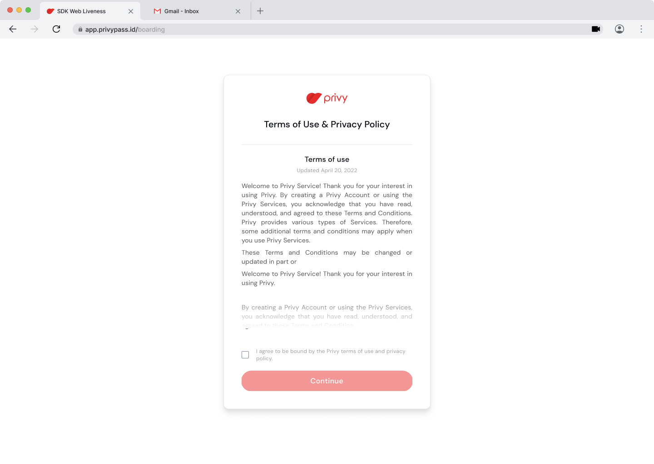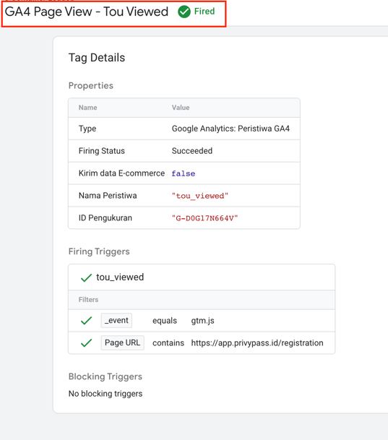

Note :

* Event_Name = Tou_agreed
* Done Implement

1. **ToU & PP Agreed ✅**

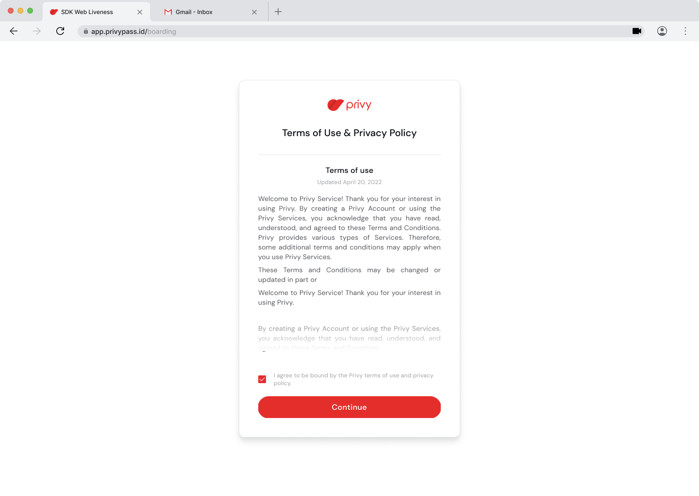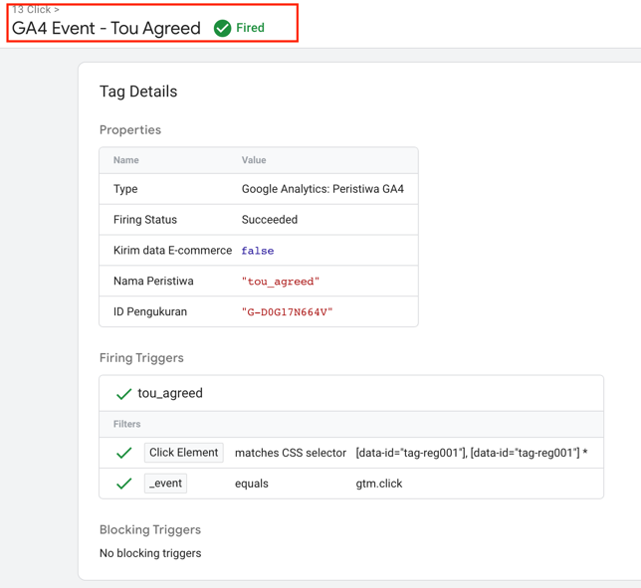

Note :

* Event_Name = Contact_info_viewed
* Done Implement

1. **Contact Info Viewed ✅**

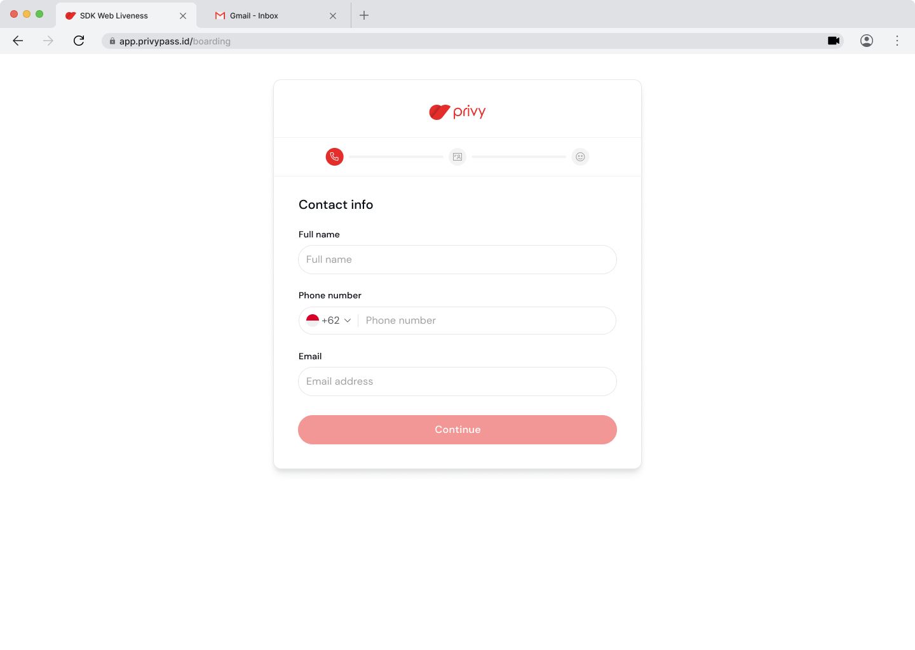 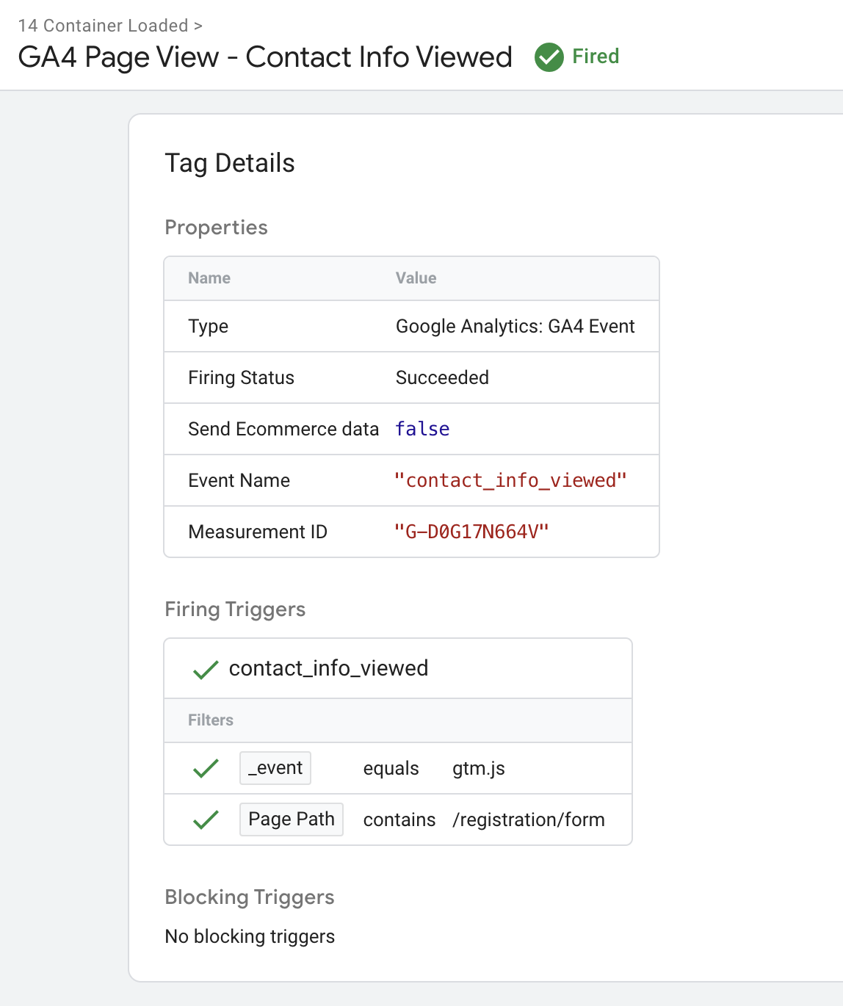

Note :

* Event_Name = contact_info_viewed
* Perlu adanya URL yang beda, path, atau # dengan tujuan pembeda tiap page

1. **Contact Info Submitted ✅**

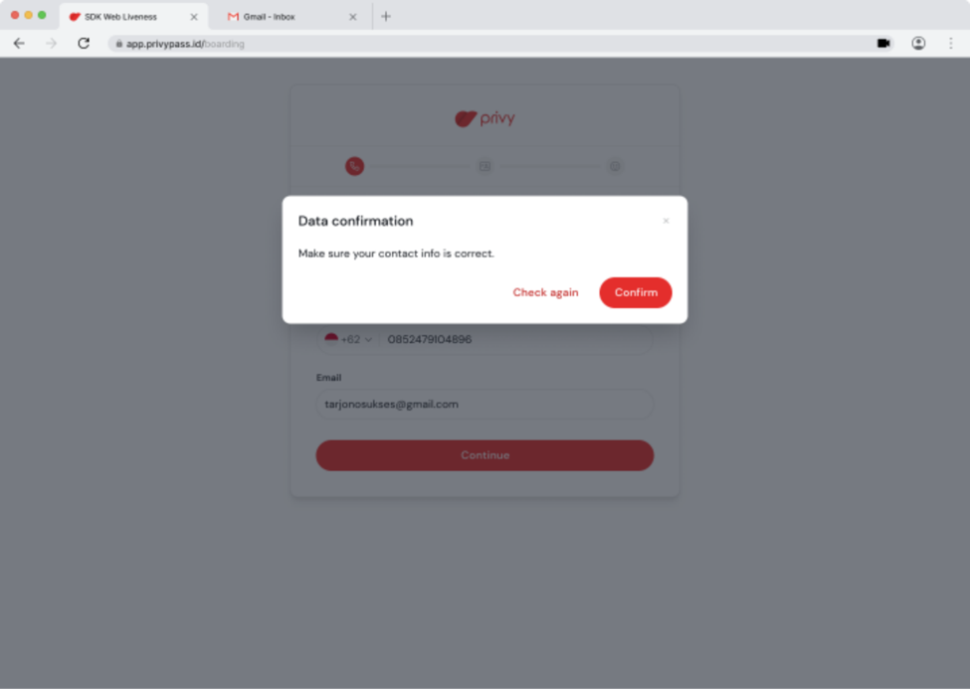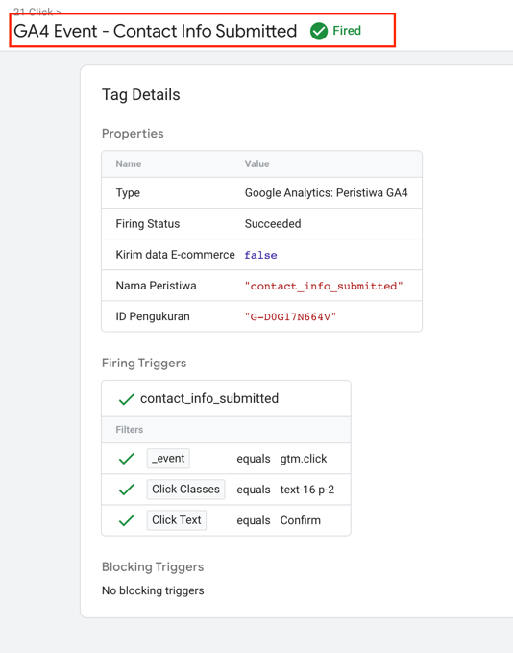

Note :

* Event_Name = contact_info_submitted
* Done Implement

1. **OTP Email Viewed ❌**

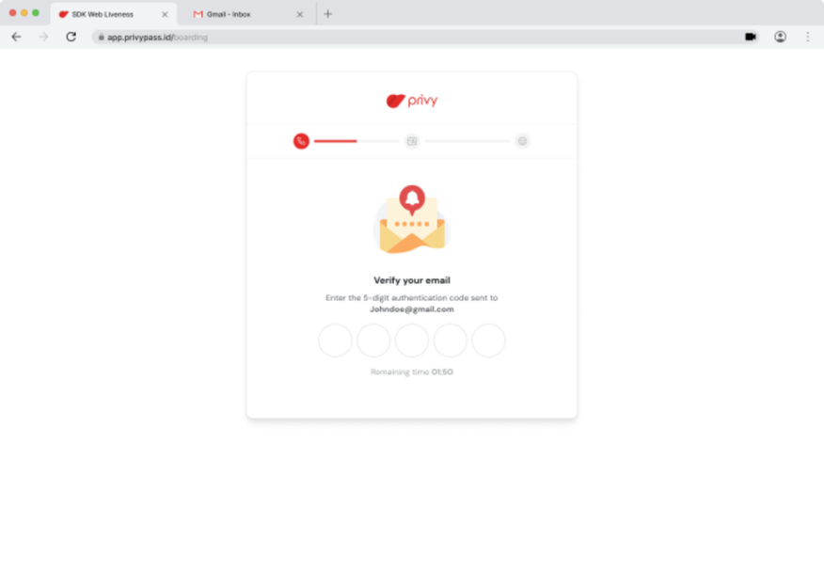

Note :

* Event_Name = otp_email_viewed
* Perlu adanya URL yang beda, path, atau # dengan tujuan pembeda tiap page

1. **Resend OTP Email ✅**

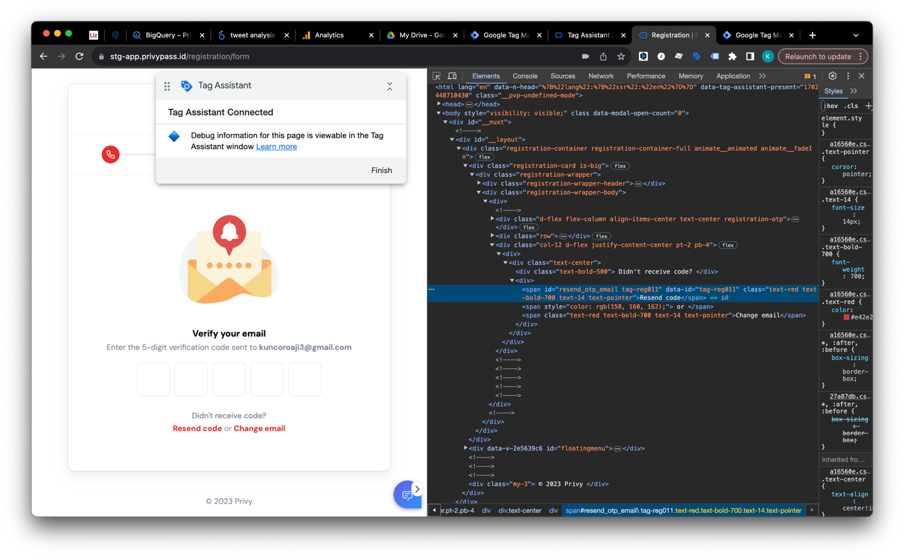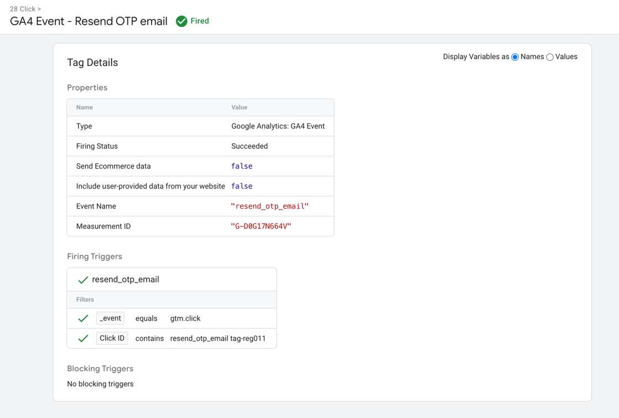

Note :

* Event_Name = resend_otp_email
* Done Implement

1. **Change Email for OTP ✅**

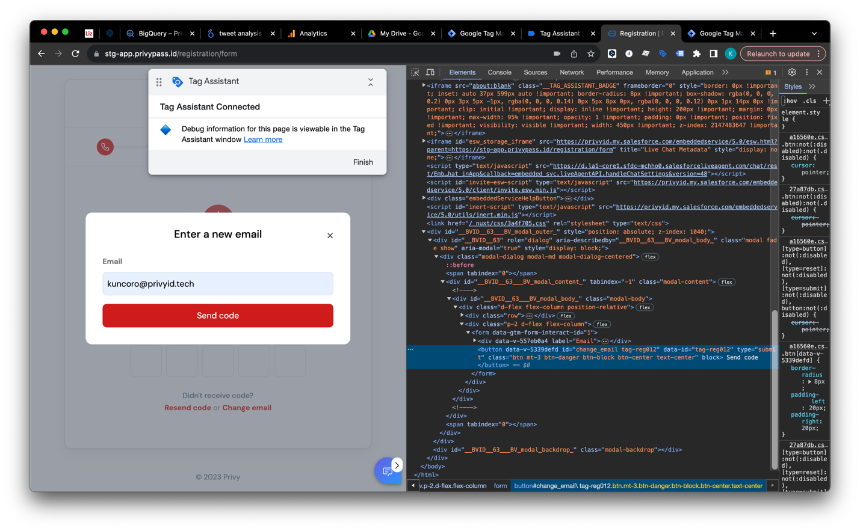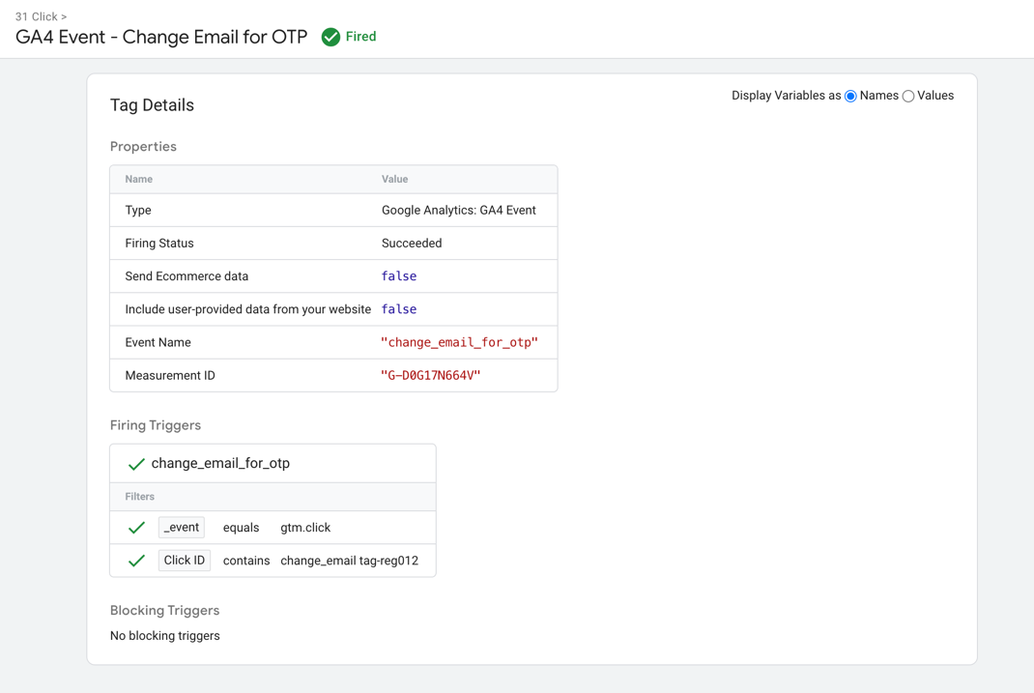

Note :

* Event_Name = change_email_for_otp
* Done Implement

1. **OTP Email Succeed ❌**

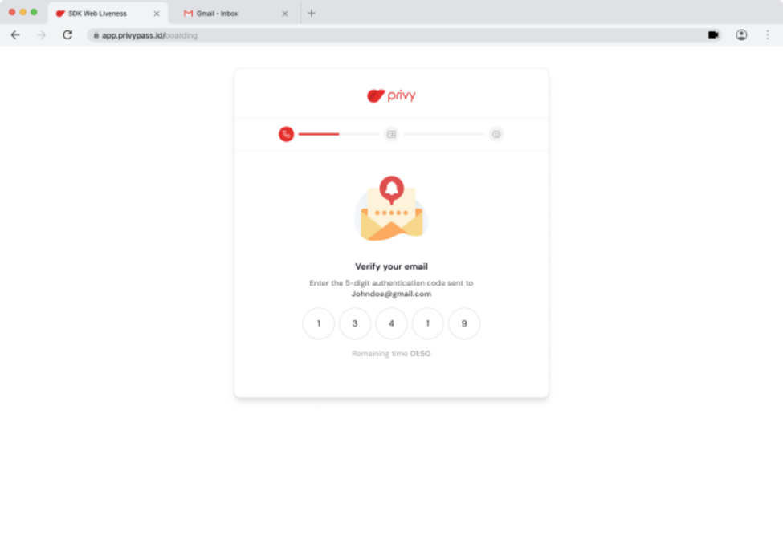

Note :

* Event_Name = otp_email_succeed
* Perlu adanya tombol untuk bisa di track eventnya

1. **OTP Phone Viewed ❌**

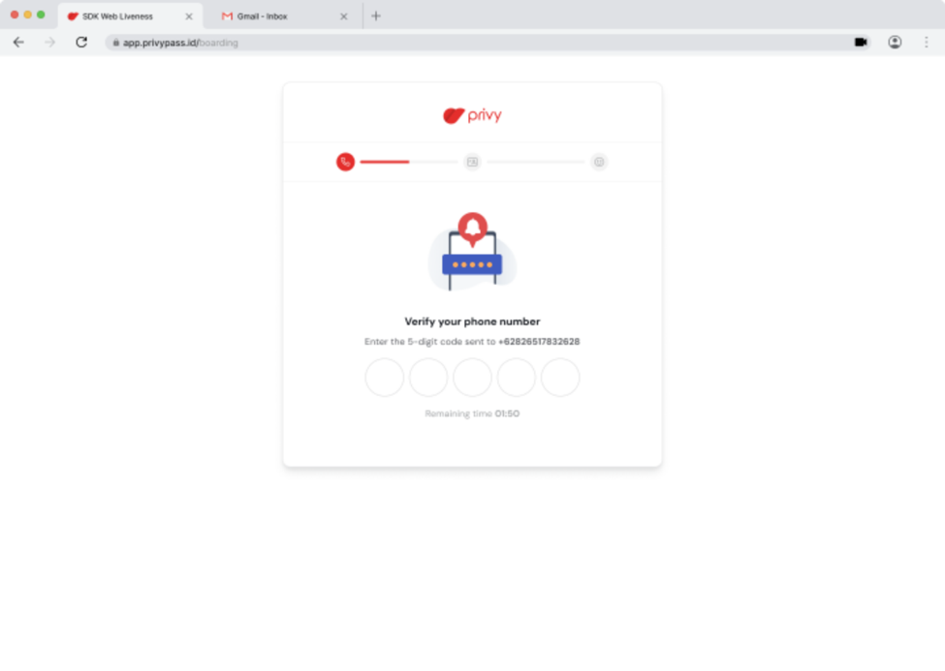

Note :

* Event_Name = otp_phone_viewed
* Perlu adanya URL yang beda, path, atau # dengan tujuan pembeda tiap page

1. **Resend OTP Phone ✅**

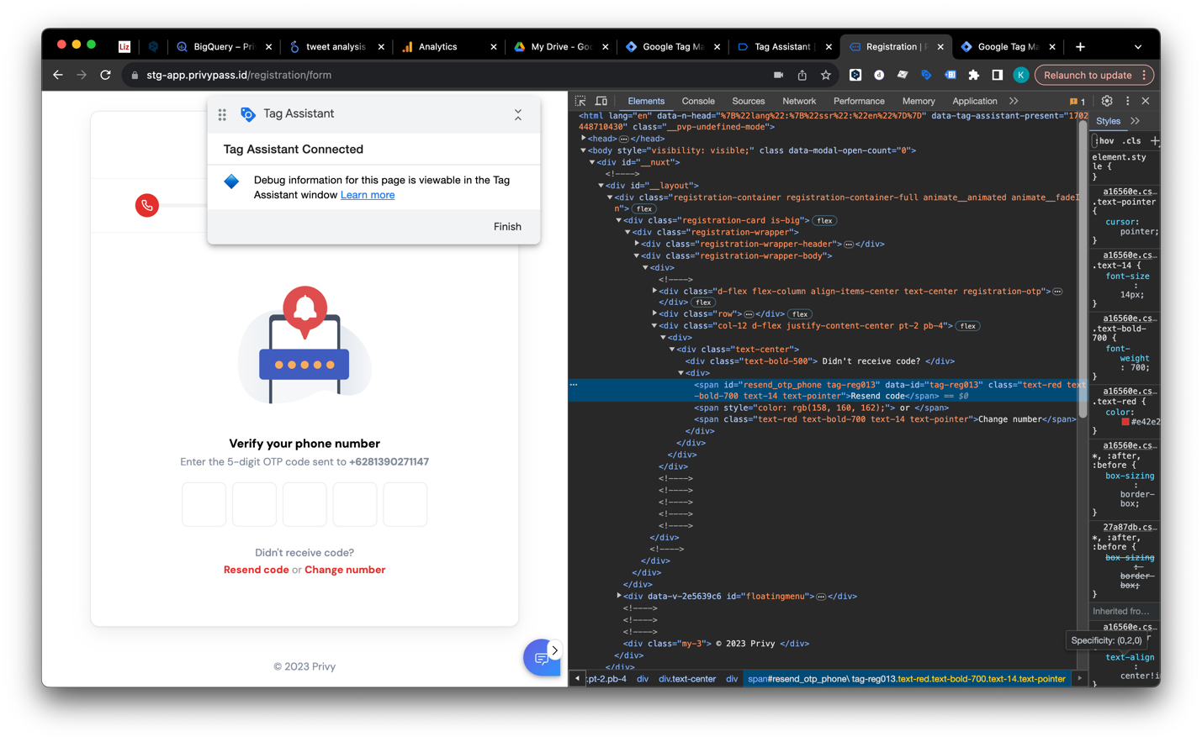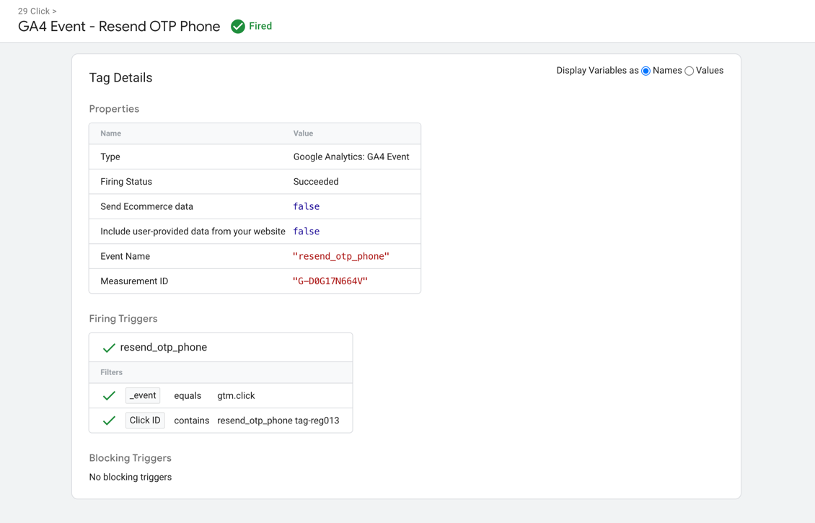

Note :

* Event_Name = resend_otp_phone
* Done Implement

1. **Change phone for OTP ✅**

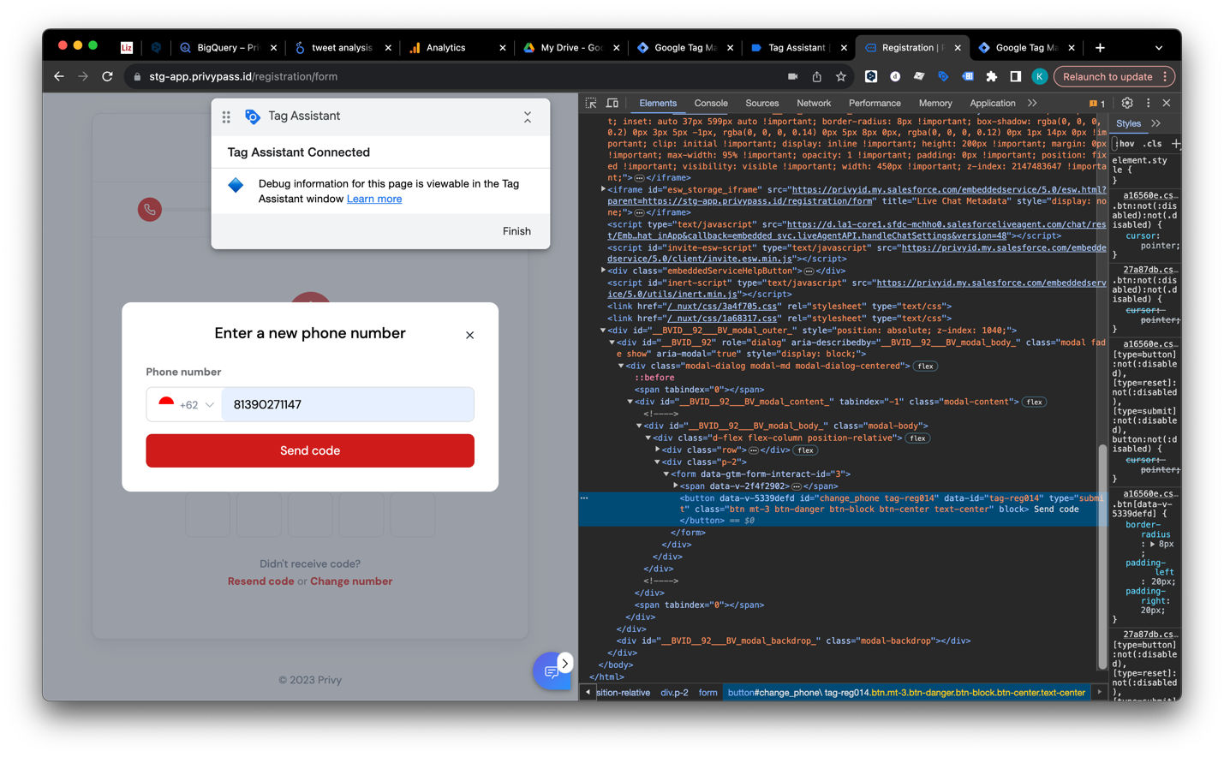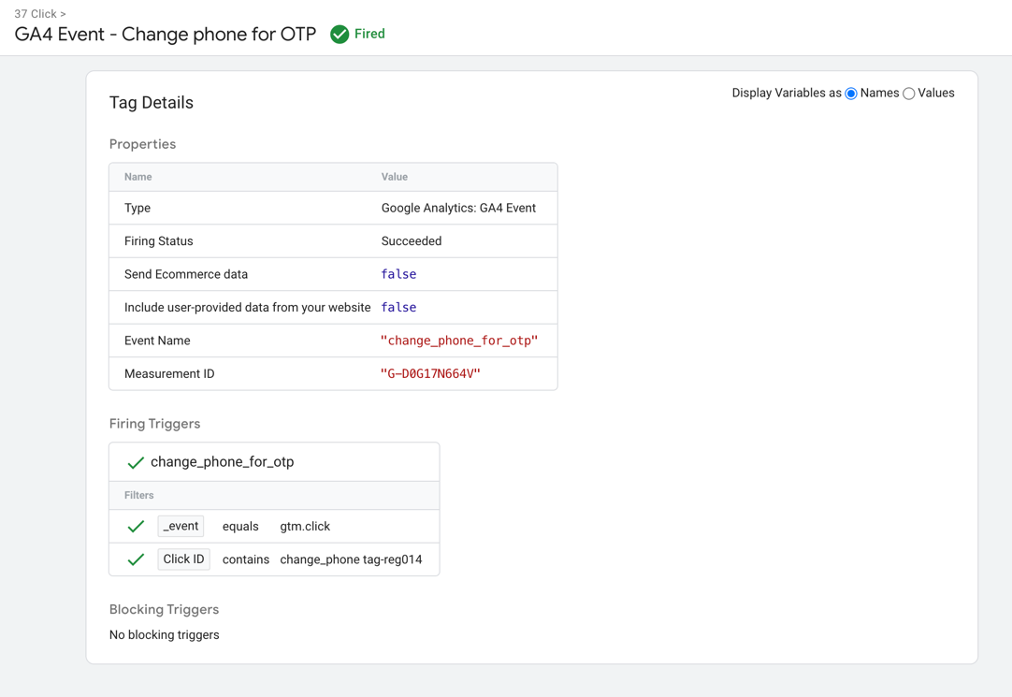

1. **OTP Phone Succeed ❌**

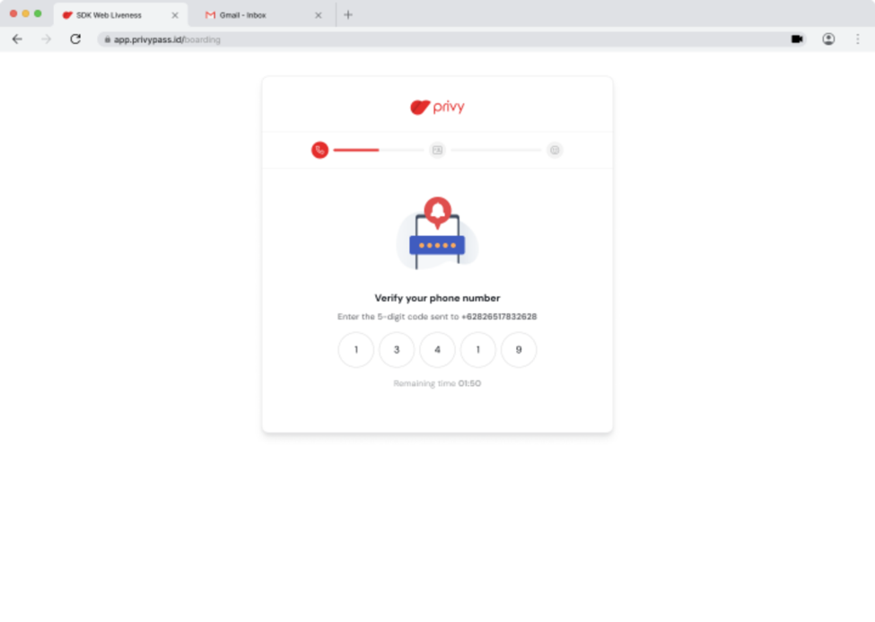

Note :

* Event_Name = otp_phone_succeed
* Perlu adanya tombol untuk bisa di track eventnya

1. **Select Citizenship Viewed ❌**

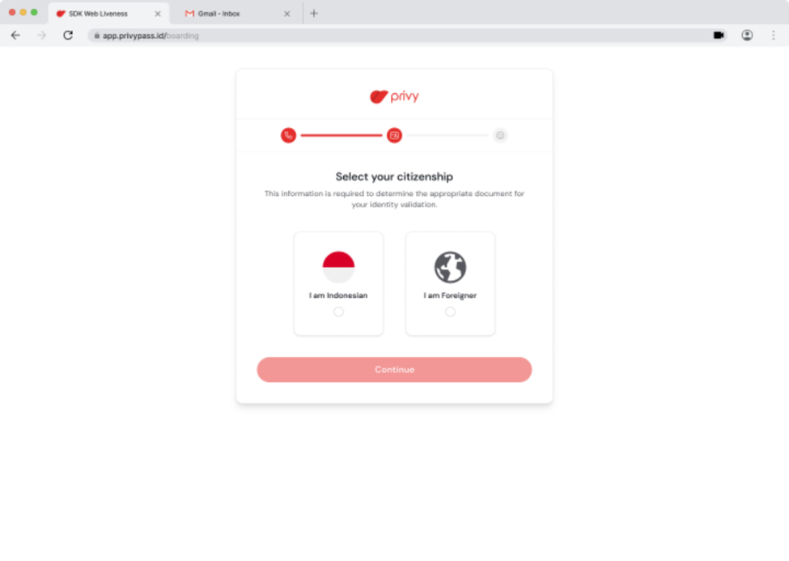

Note :

* Event_Name = citizenship_viewed
* Perlu adanya URL yang beda, path, atau # dengan tujuan pembeda tiap page

1. **Indonesian Selected ✅**

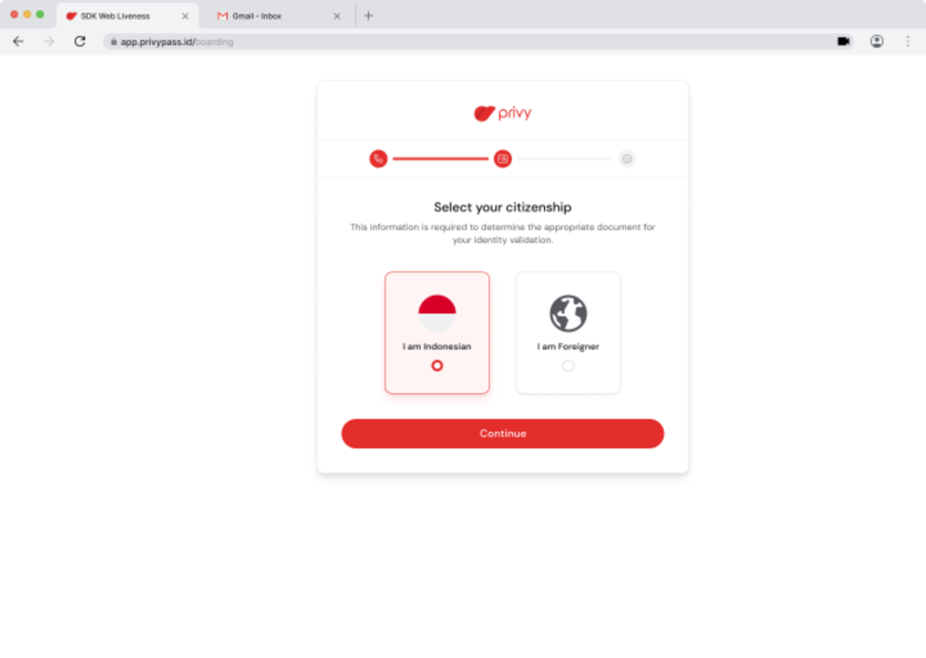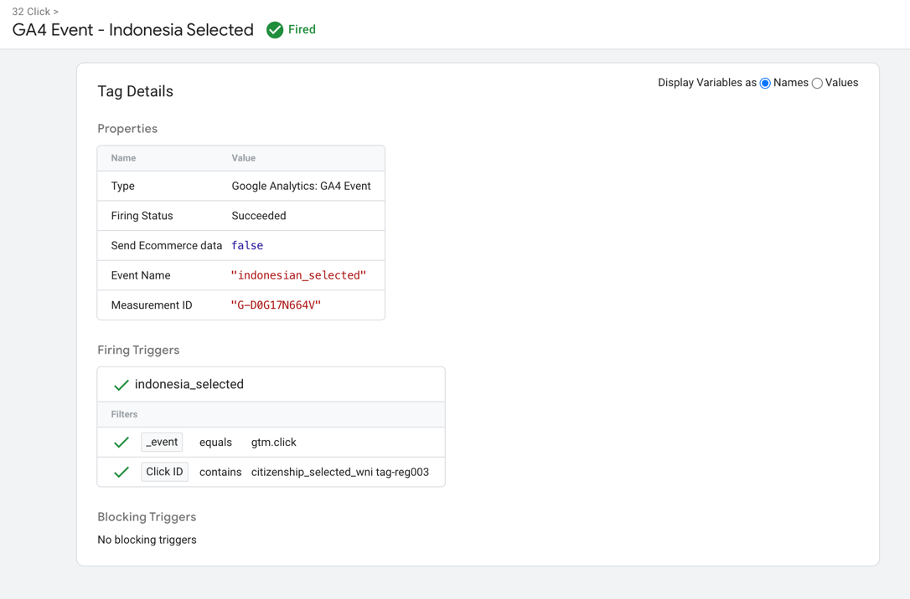

Note :

* Event_Name = indonesian_selected
* Done Implement

1. **Onboard OCR Viewed ❌**

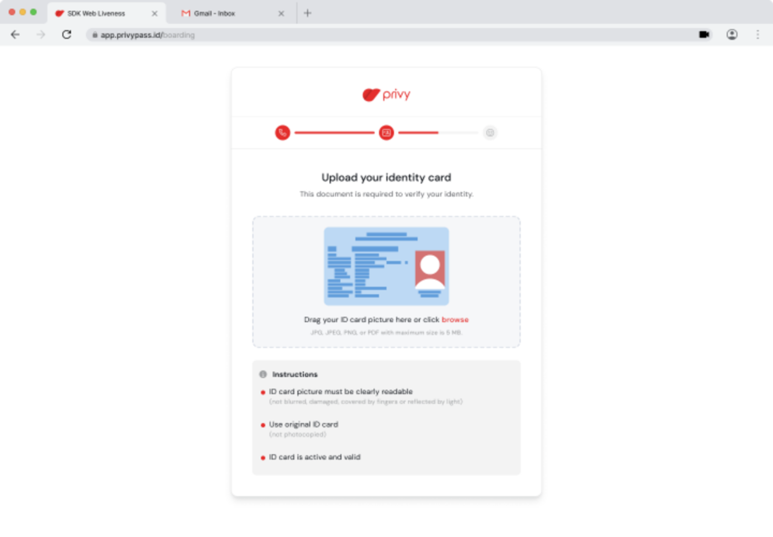

Note :

* Event_Name = onboard_ktp_wni_viewed
* Perlu adanya URL yang beda, path, atau # dengan tujuan pembeda tiap page

1. **OCR Continued ✅**

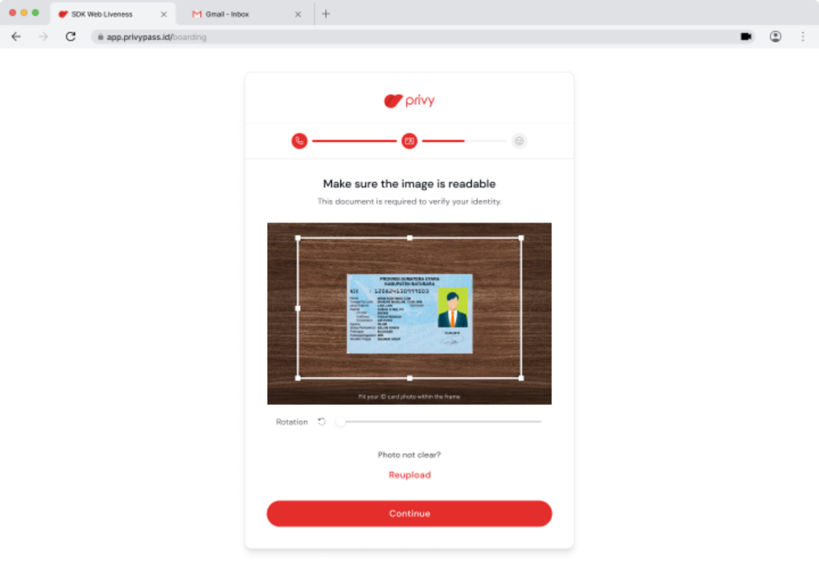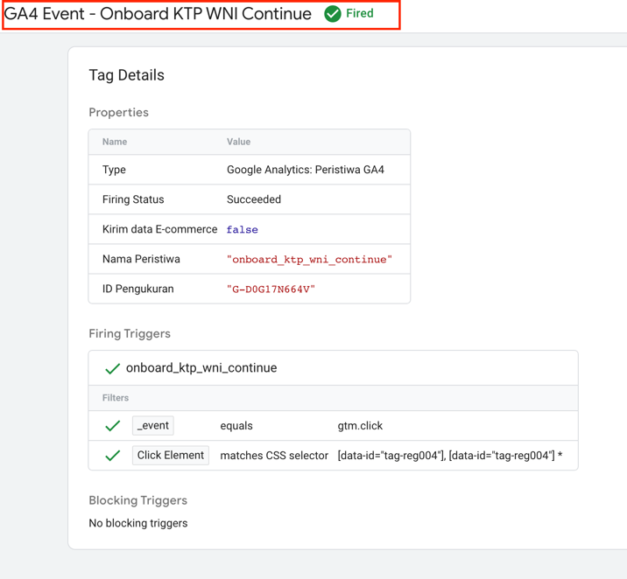

Note :

* Event_Name = onboard_ktp_wni_continue
* Done Implement

1. **Reupload KTP ✅**

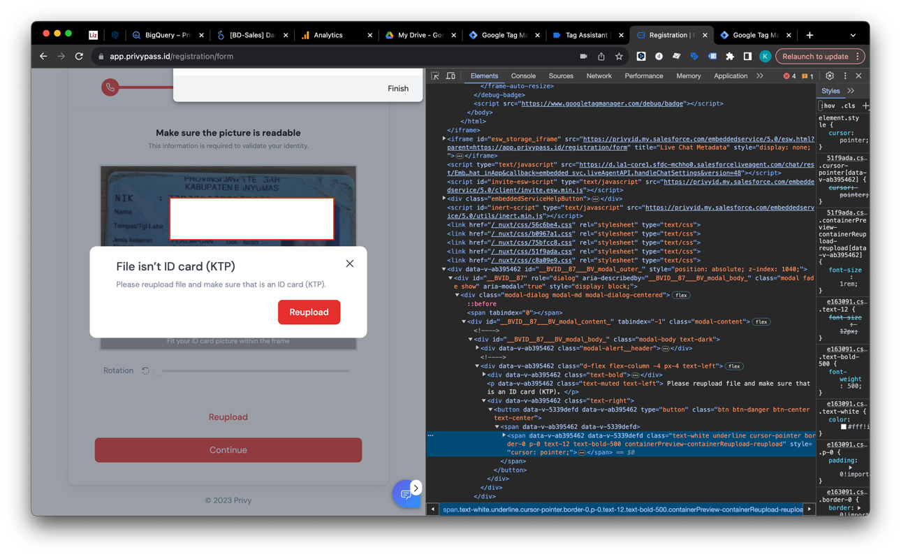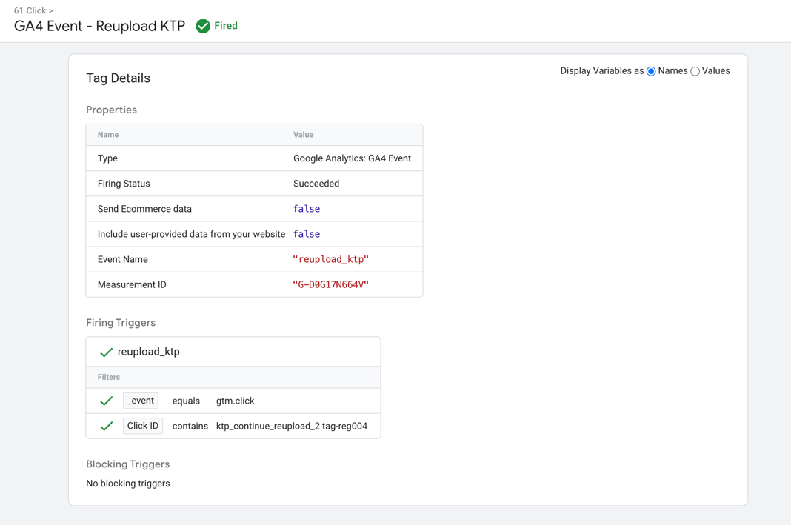

Note :

* Event_Name = reupload_ktp
* Done Implement

1. **Personal Info Viewed ❌**

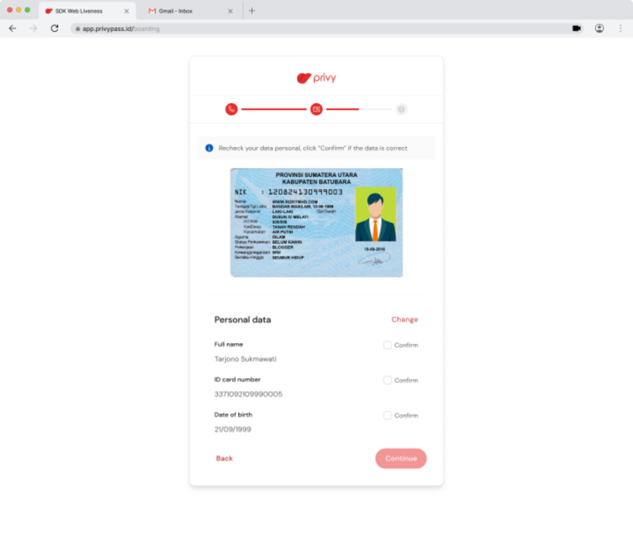

Note :

* Event_Name = personal_data_viewed
* Perlu adanya URL yang beda, path, atau # dengan tujuan pembeda tiap page

1. **Personal Data Confirmed ✅**

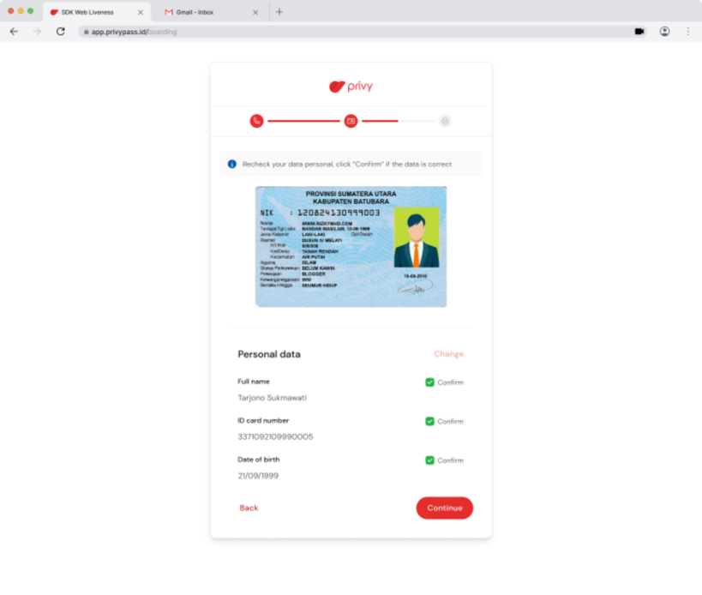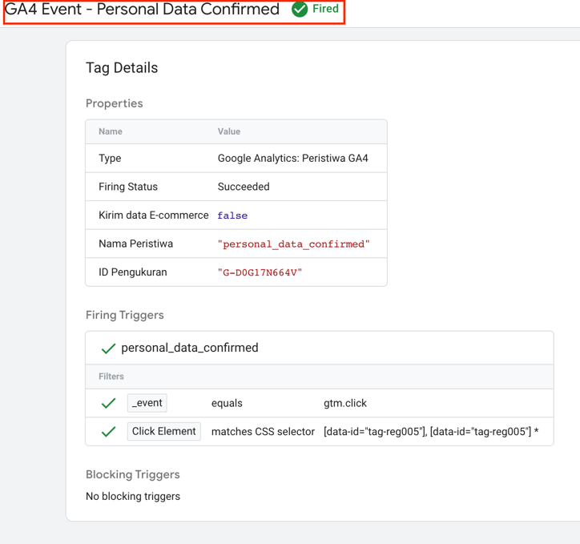

Note :

* Event_Name = personal_data_confirmed
* Done Implement

1. **Onboard Liveness Viewed ❌**

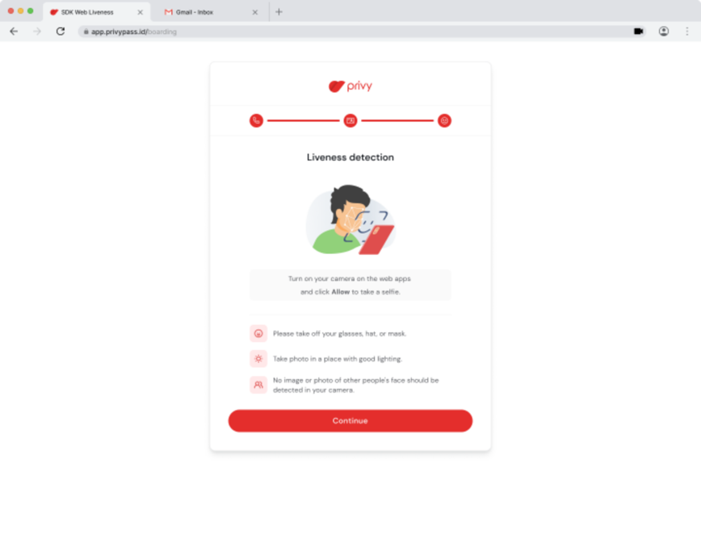

Note :

* Event_Name = onboard_liveness_viewed
* Perlu adanya URL yang beda, path, atau # dengan tujuan pembeda tiap page

1. **Liveness Continued ✅**

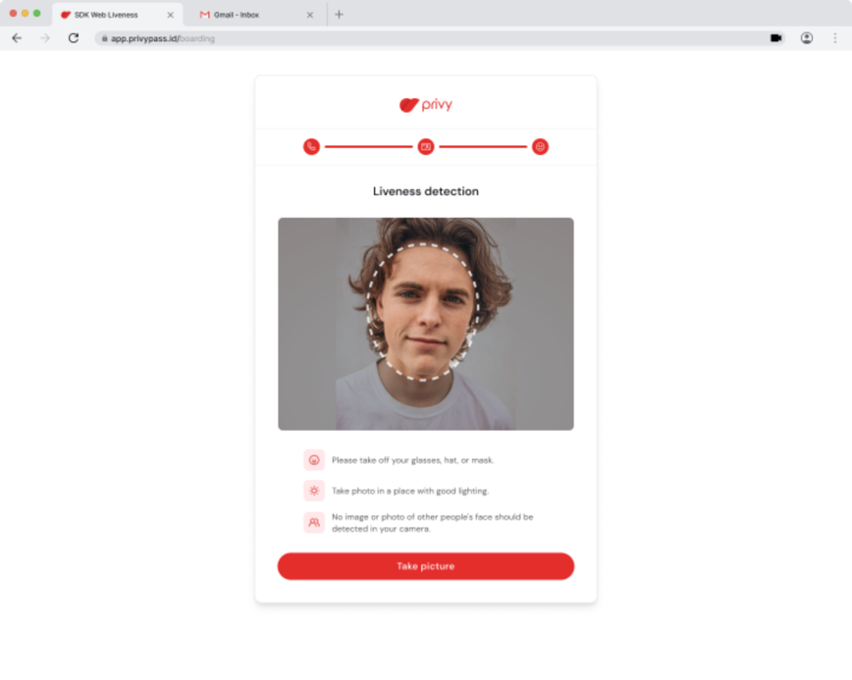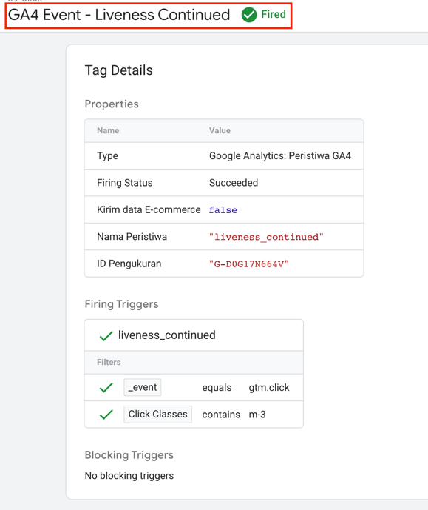

Note :

* Event_Name = liveness_continued
* Done Implement

1. **Liveness Succeed ✅**

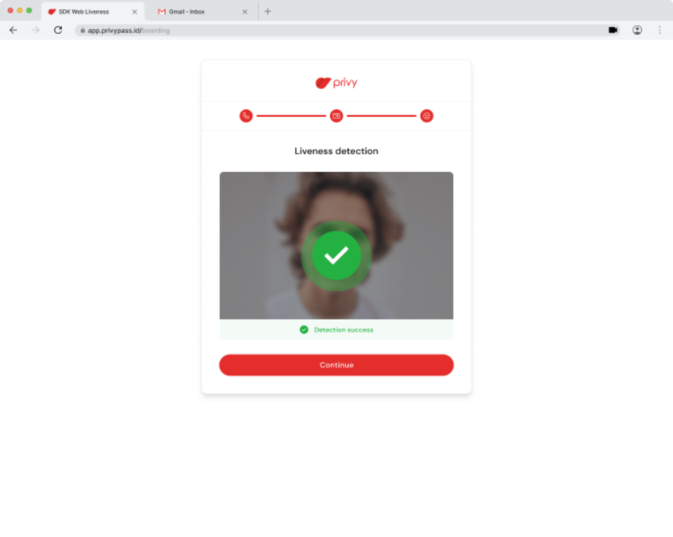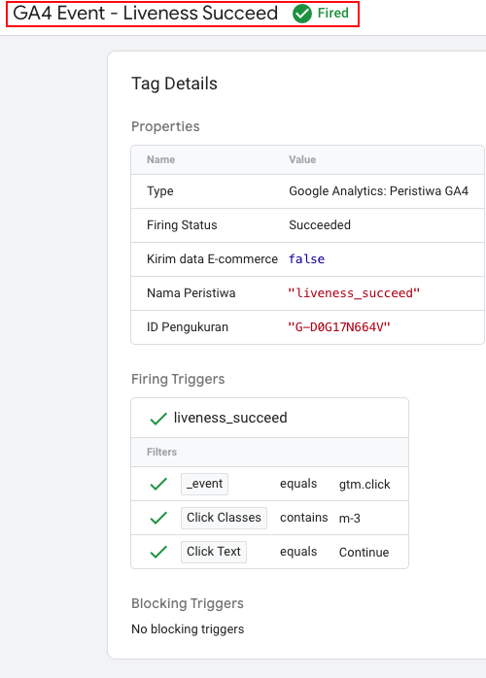

Note :

* Event_Name = liveness_succeed
* Done Implement

1. **Waiting Verif Viewed ✅**

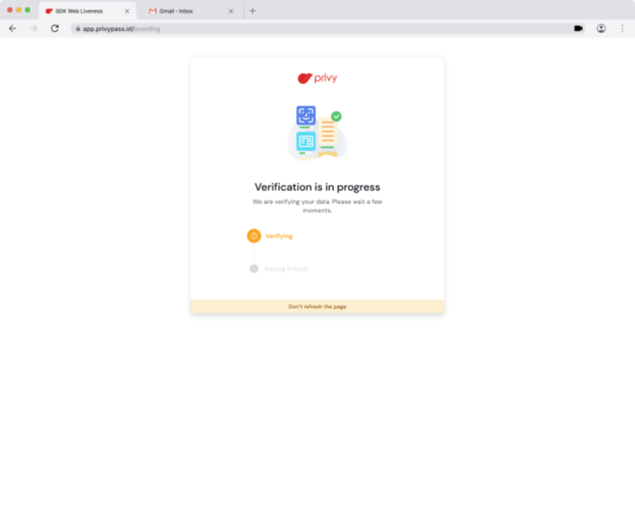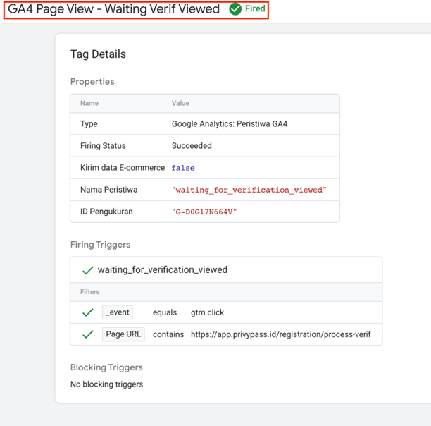

Note :

* Event_Name = waiting_for_verification_viewed
* Done Implement

1. **Verified Success ✅**

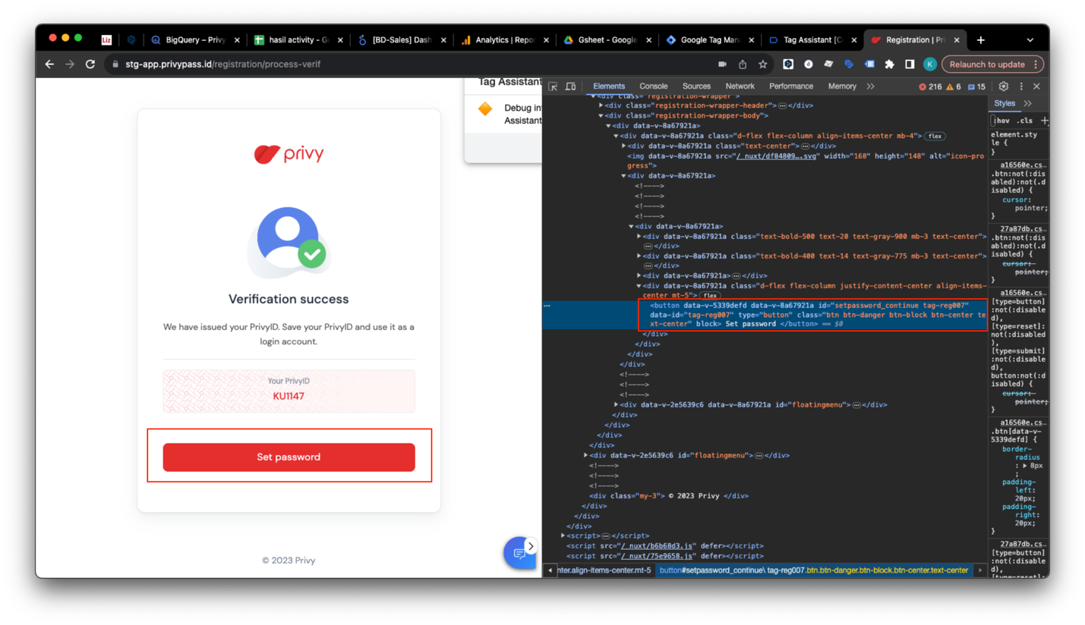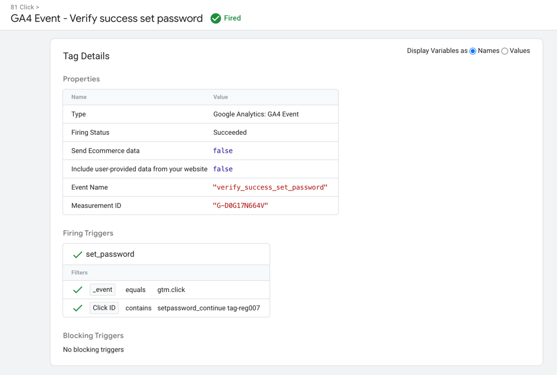

Note :

* Event_Name = verify_success_set_password
* Done Implement

1. **Success Set Password ✅**

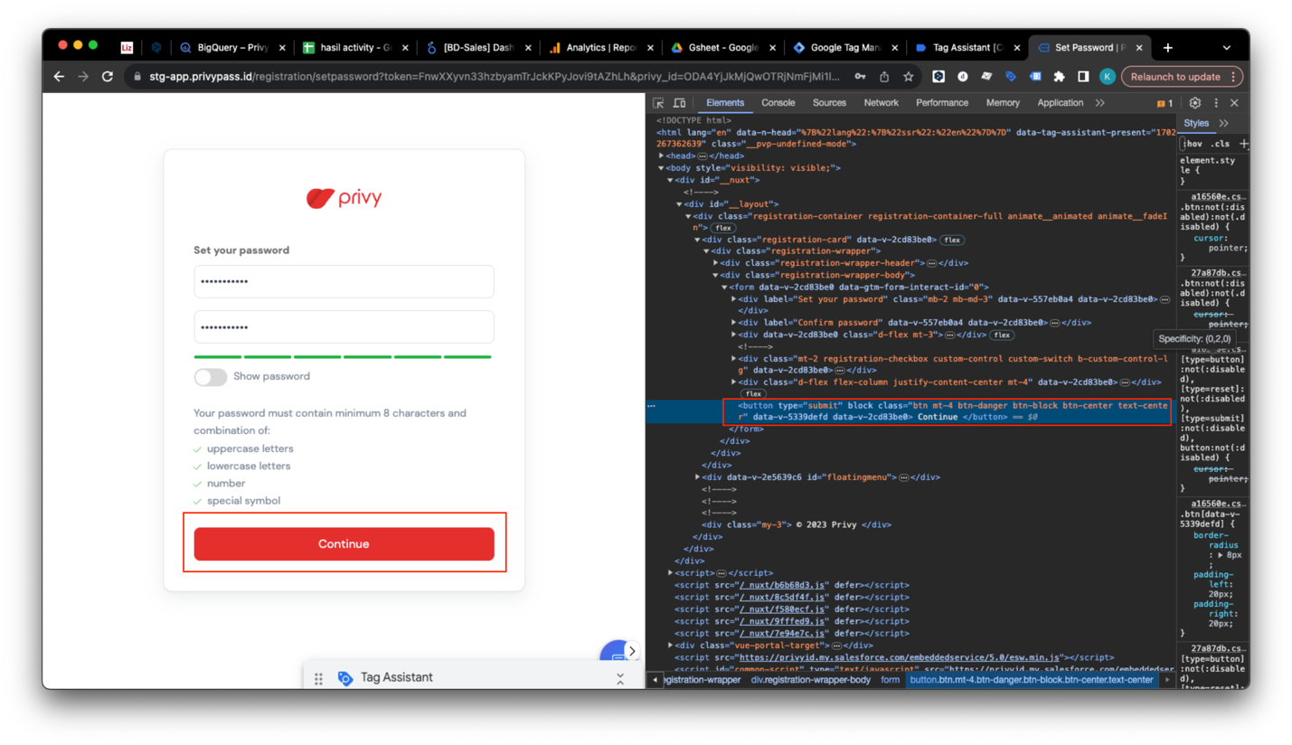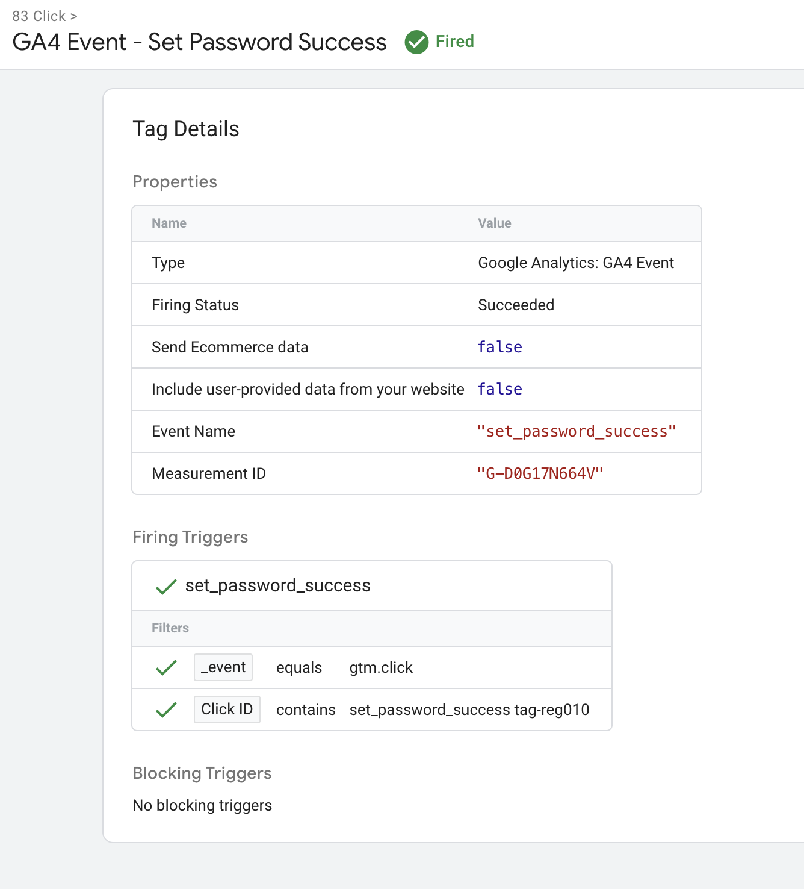

Note :

* Event_Name = set_password_success
* Done Implement

1. **Login After Registration ✅**

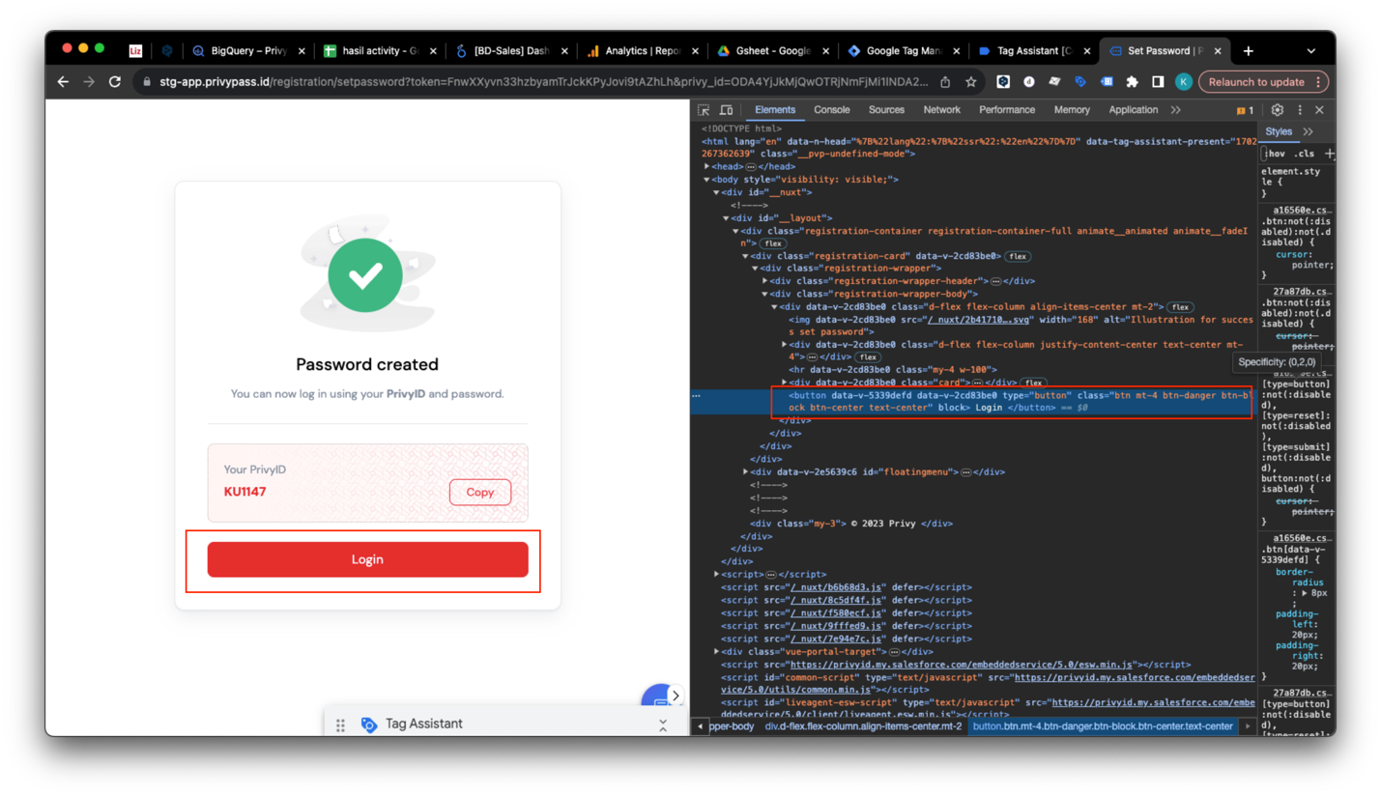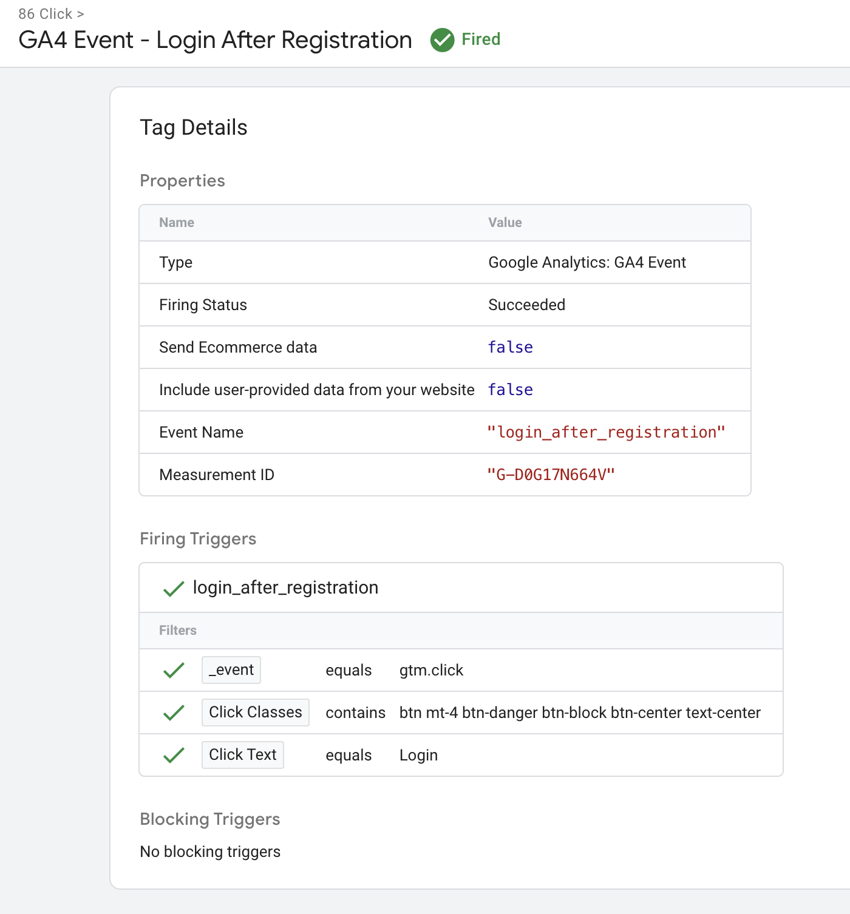

* Event_Name = login_after_registration
* Done Implement